**Topics: Normal distribution, Functions of Random Variables**

1. The time required for servicing transmissions is normally distributed with *μ* = 45 minutes and *σ* = 8 minutes. The service manager plans to have work begin on the transmission of a customer’s car 10 minutes after the car is dropped off and the customer is told that the car will be ready within 1 hour from drop-off. What is the probability that the service manager cannot meet his commitment?
2. 0.3875
3. 0.2676
4. 0.5
5. 0.6987

**Ans:** The work begins 10 min after the drop off. Hence the new time will be *μ = 45 + 10 = 55 min*

m = 55

std = 8

q1 = stats.norm.sf(60, loc = m, scale = std)

print("""The probability that the service manager cannot meet his

commitment is""",np.round(q1,5))

The probability that the service manager cannot meet his commitment is 0.26599.

1. The current age (in years) of 400 clerical employees at an insurance claims processing center is normally distributed with mean *μ* = 38 and Standard deviation *σ* =6. For each statement below, please specify True/False. If false, briefly explain why.
2. More employees at the processing center are older than 44 than between 38 and 44.

**Ans:** False, because the employees that are between the age 38 and 44 has higher probability than the probability of employees that are older than age 44.

1. A training program for employees under the age of 30 at the center would be expected to attract about 36 employees.

**Ans:** True

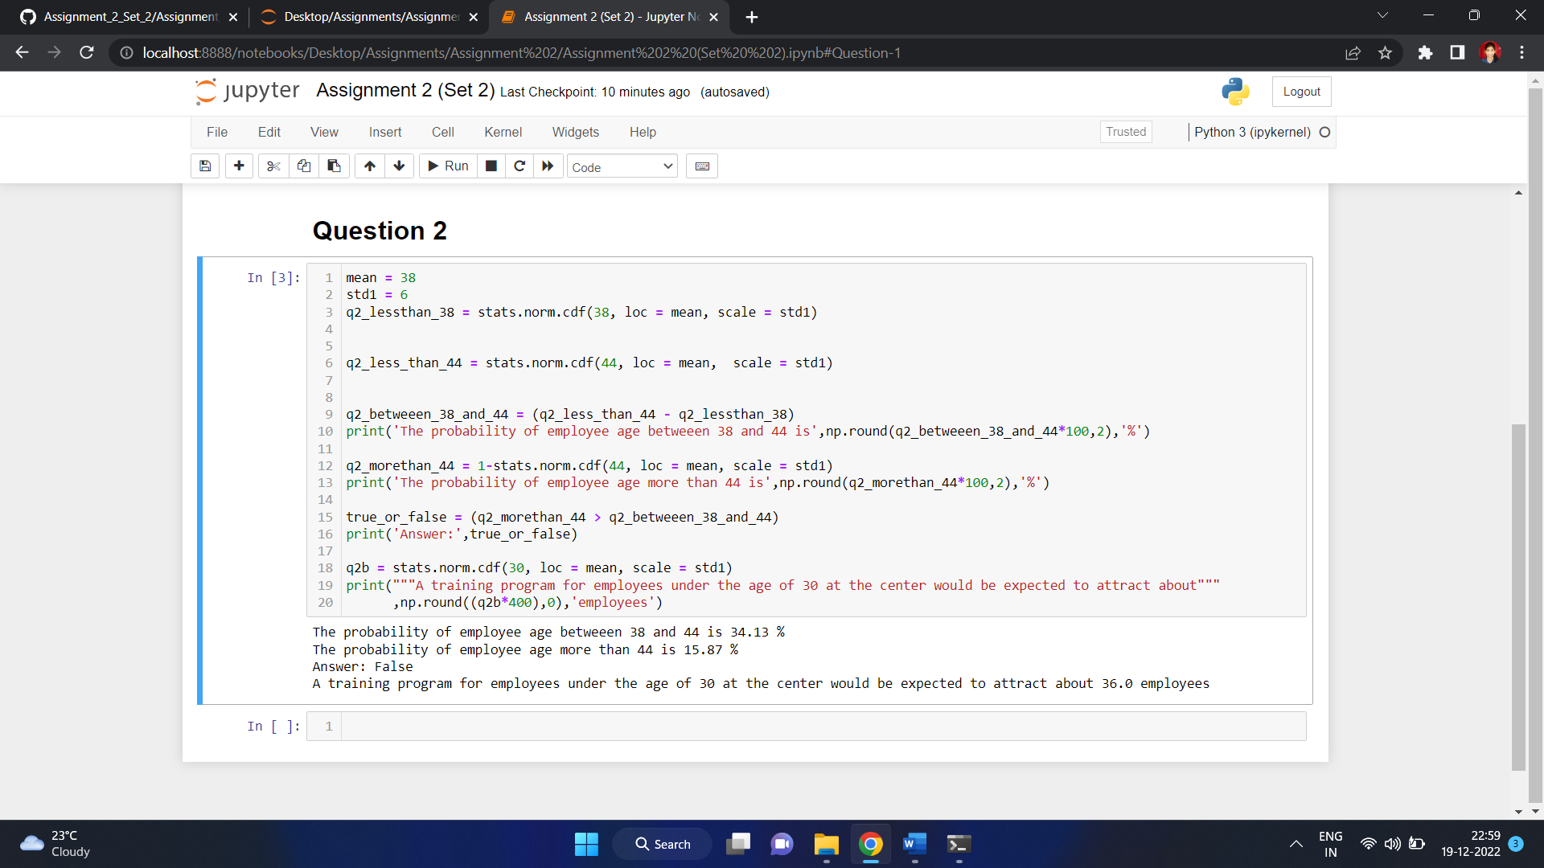

1. If *X1* ~ *N*(μ, σ2) and *X*2 ~ *N*(μ, σ2) are *iid* normal random variables, then what is the difference between 2 *X*1 and *X*1 + *X*2? Discuss both their distributions and parameters.

**Ans:**

According to the Central limit theorem, any large sum of independent, identically distributed (iid) random variables is approximately Normal.The Normal distribution is defined by two parameters, Mean (μ) and variance (σ2) and written as *X* ~ *N*(μ, σ2).

*X1* ~ *N*(μ, σ2) and *X2* ~ *N*(μ, σ2) are two independent identically distributed random variables.

If *X* ~ *N*(μ1, σ21) and *Y* ~ *N*(μ2, σ22) are the two iids,

* The sum (X + Y) would be -

X + Y ~ N(μ1 + μ2 , σ21 + σ22)

* The difference (X – Y) would be -

X - Y ~ N(μ1 - μ2 , σ21 + σ22)

* When Z = aX, the product of X is given by –

Z ~ N (aμ1, a2σ21)

* When Z = aX + bY, the linear combination of X and Y is given by-

Z ~ N (aμ1 + bμ2, a2σ21  + b2 σ22)

To find 2X1,

* Multiplication –

2X1 ~ N(2μ, 4σ2)

* Addition –

X1 + X2 ~ N(2μ, 2σ2)

* Difference between the two –

2X1 - (X1 + X2) ~ N(0, 6σ2)

Hence the difference between 2X1 and X1 is N(0, 6σ2).

The mean of 2X1 and X1 + X2 is same but the variance (σ2) is **2** times more than the variance of

X1 + X2.

The difference between the two says that the two given variables are independently and identically distributed.

1. Let X ~ N(100, 202). Find two values, *a* and *b*, symmetric about the mean, such that the probability of the random variable taking a value between them is 0.99.
2. 90.5, 105.9
3. 80.2, 119.8
4. 22, 78
5. 48.5, 151.5
6. 90.1, 109.9

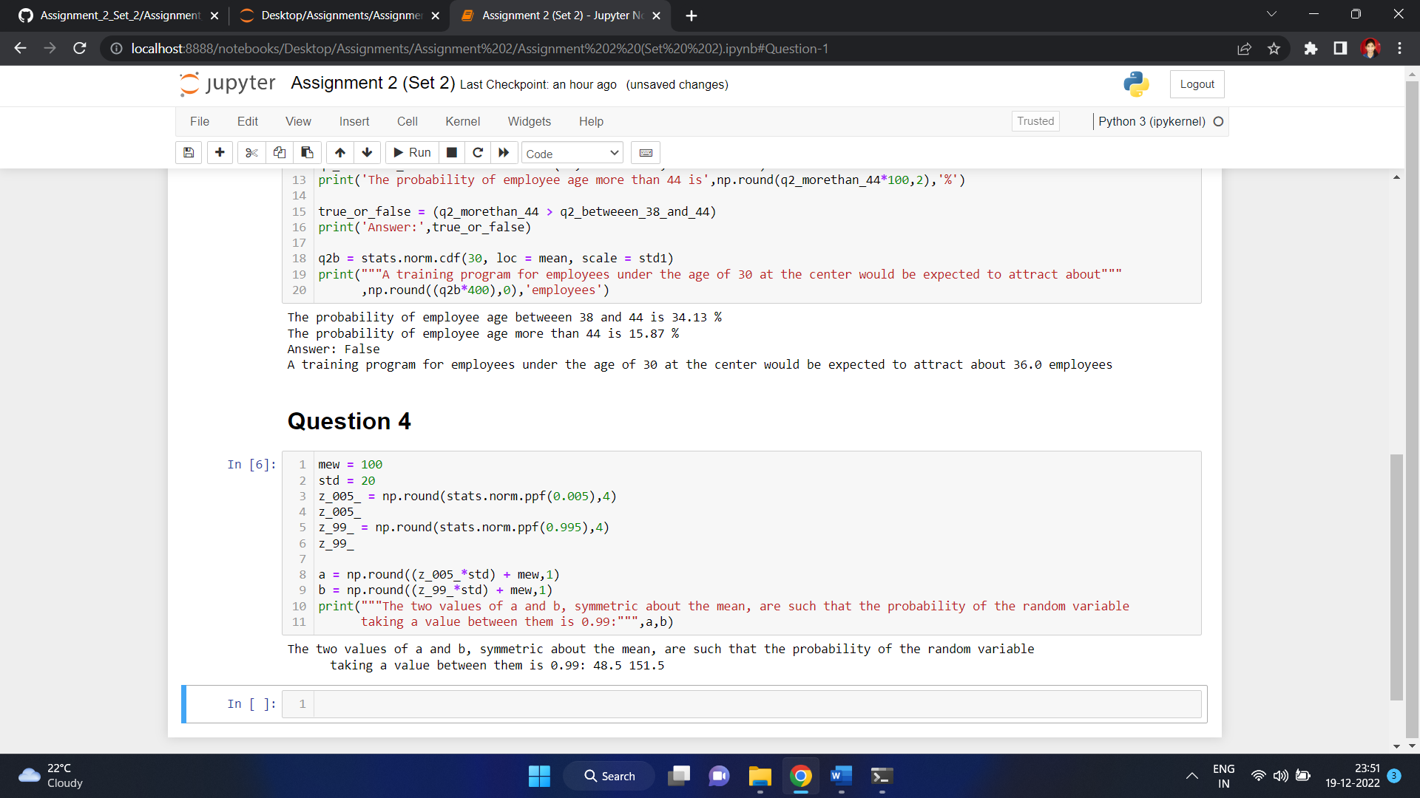

The values are –

a = 0.99

b = 151.5

1. Consider a company that has two different divisions. The annual profits from the two divisions are independent and have distributions Profit1 ~ N(5, 32) and Profit2 ~ N(7, 42) respectively. Both the profits are in $ Million. Answer the following questions about the total profit of the company in Rupees. Assume that $1 = Rs. 45

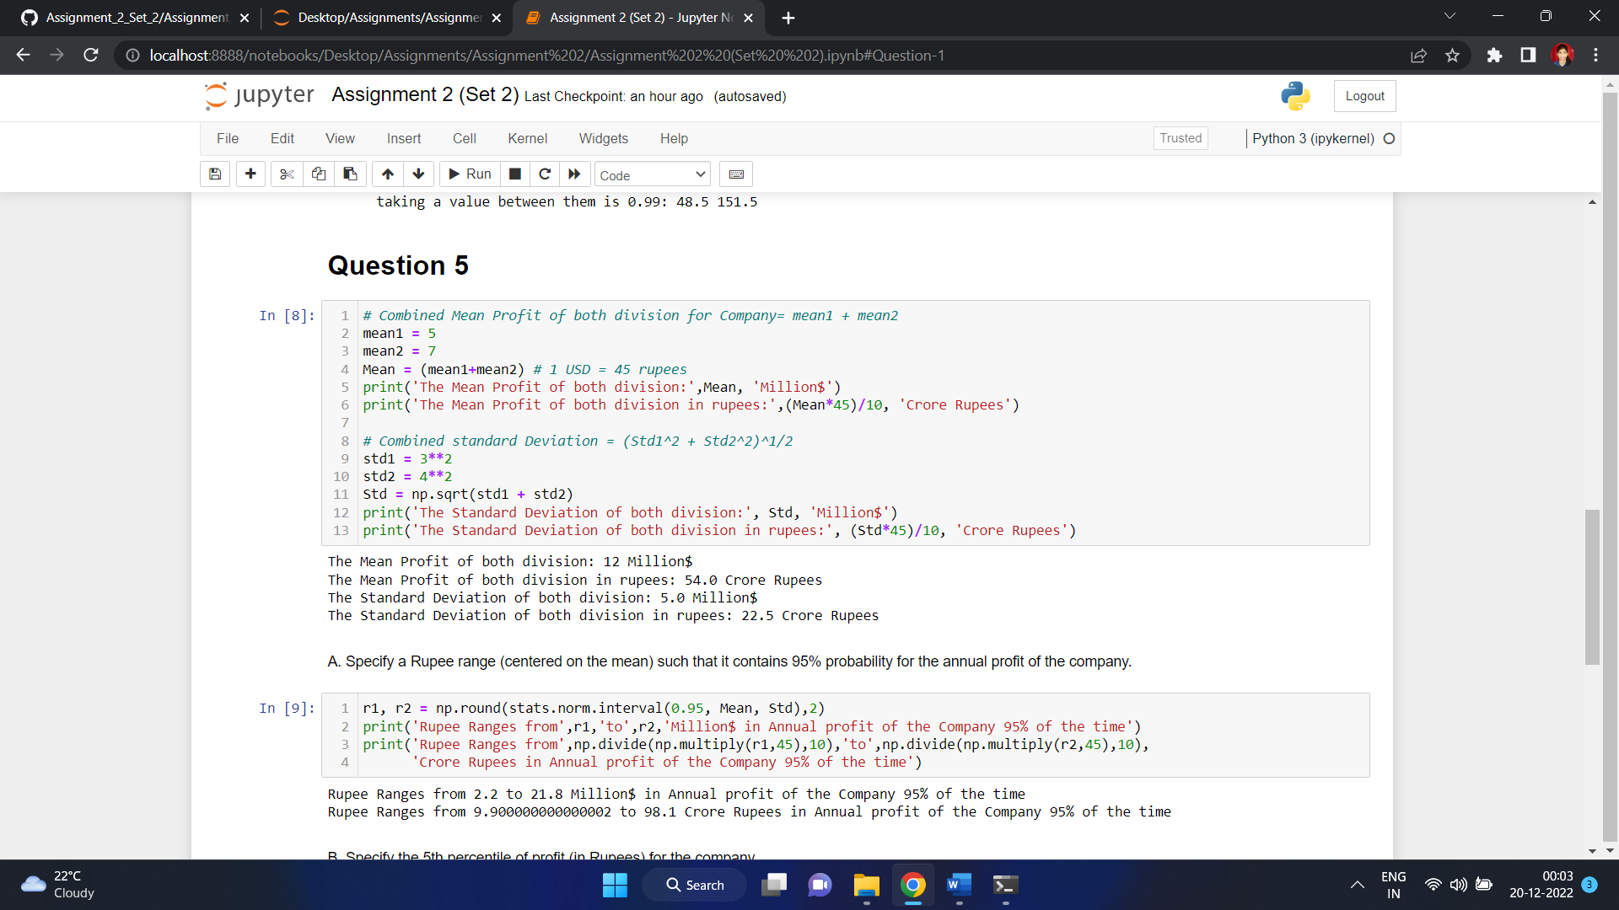

1. Specify a Rupee range (centered on the mean) such that it contains 95% probability for the annual profit of the company.

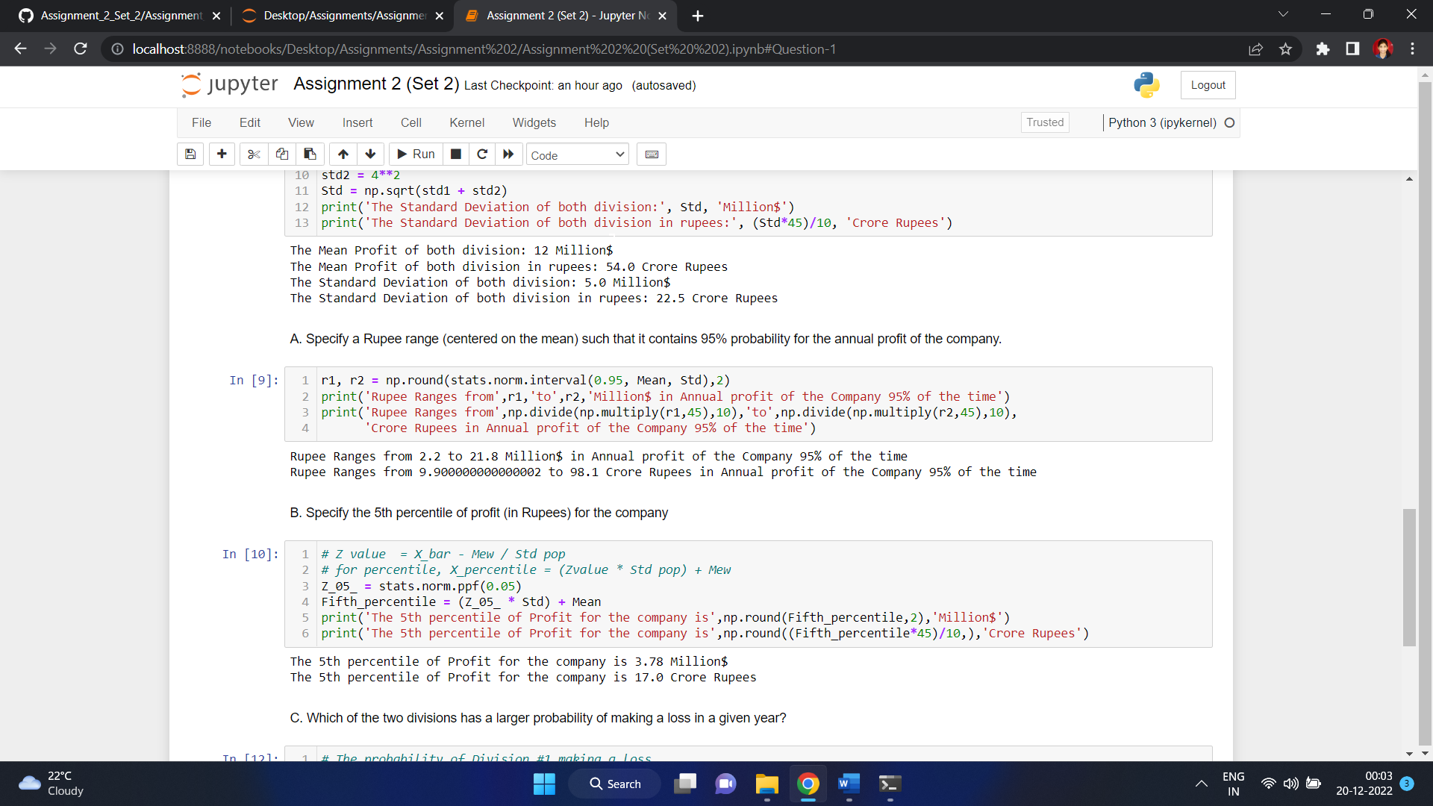

1. Specify the 5th percentile of profit (in Rupees) for the company



1. Which of the two divisions has a larger probability of making a loss in a given year?

